Definitions of echo parameters for joint paper on Nt-proBNp and Troponin T reference values.
LEFT VENTRICLE MYOCARDIAL MASS AND HYPERTROPHY (LVMM and LVH)
1 ) LV MASS Cube formula:
0.8x(1.04x(((LV end diastolic diameter (cm)+interventricular septum diameter (cm)+lv posterior wall diameter (cm))³)))+0.6 g.

SAS code:
0.8*(1.04*(((LVIDD_T72+IVSDMMODE_T72+LWPWDMMODE_T72)**3-LVIDD_T72**3)))+0.6

2) LVMM index
Defined as left ventricle myocardial mass (g) indexed by body surface area (BSA)

bsa=0.007184*(weight_t7**0.425)*(height_t7**0.725);

or Height^{2.7}. Please note that for BSA indexation you need height in cm (as it was measured in Tromsø 7), but for Height^{2.7} indexation you should use height in meters.

heightm=height_t7/100;

I use Height^{2.7} indexation according to the latest European society of Cardiology recommendations on Arterial Hypertension treatment (2018), however using of BSA is also applicable. More info on different indexation methods here:

https://www.asecho.org/wp-content/uploads/2015/01/ChamberQuantification2015.pdf - page 16, paragraph 3
https://academic.oup.com/eurheartj/article/39/33/3021/5079119 - table 17

3 ) LVMMi calculation

lvmmi=lvmm/bsa;
or
lvmmi=lvmm/heightm**2.7;

Reference values:
Echocardiographic definitions of left ventricular hypertrophy, concentric geometry, left ventricular chamber size
Parameter | Measure | Abnormality threshold
LVH | LV mass/height^{2.7} (g/m^{2.7}) | >50 (men)
LVH | LV mass/height^{2.7} (g/m^{2.7}) | >47 (women)
LVH | LV mass/BSA (g/m²) | >115 (men)
LVH | LV mass/BSA (g/m²) | >95 (women)

My SAS code for LVH:
*LVH;
lvlarge=0;
if (lvmmi>50 and sex_t7=1) or (lvmmi>47 and sex_t7=0) then lvlarge=1;
if lvmmi=. then lvlarge=.;

Heart failure
Heart failure echo classification (2016):
https://academic.oup.com/eurheartj/article/37/27/2129/1748921

Table 3.1
Definition of heart failure with preserved (HFpEF), mid-range (HFmrEF) and reduced ejection fraction (HFrEF)
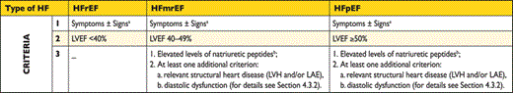
BNP = B-type natriuretic peptide; HF = heart failure; HFmrEF = heart failure with mid-range ejection fraction; HFpEF = heart failure with preserved ejection fraction; HFrEF = heart failure with reduced ejection fraction; LAE = left atrial enlargement; LVEF = left ventricular ejection fraction; LVH = left ventricular hypertrophy; NT-proBNP = N-terminal pro-B type natriuretic peptide.
aSigns may not be present in the early stages of HF (especially in HFpEF) and in patients treated with diuretics.
bBNP>35 pg/ml and/or NT-proBNP>125 pg/mL.

SAS codes for different types of HF:
HFrEF
hfref=0;
if 0<LVEFBIPLANE_T72<40 then hfref=1;
HFmrEF
hfmref=0;
if (40=<LVEFBIPLANE_T72<50 and S_PRO_BNP_T72>125) and (lvlarge=1 or lalarge=1 or dfunc=3) then hfmref=1;

HFpEF
hfpef=0;
if (LVEFBIPLANE_T72>=50 and S_PRO_BNP_T72>125) and (lvlarge=1 or lalarge=1 or dfunc=3) then hfpef=1;
You also need left atrial volume indexed by BSA or Height^{2.7} and diastolic dysfunction to estimate HFmrEF and HFpEF. See info on Diastolic dysfunction in separate part.
Definition of left atrial enlargement:

lavi= LAESV_MOD_BP_T72/bsa;

*LAH;
lalarge=0;
if (lavi>34 and sex_t7=1) or (lavi>34 and sex_t7=0) then lalarge=1;
if lavi=. then lalarge=.;

For BSA indexed LA volume the threshold is 34 ml/m² both for men and women
In case of using Height^{2.7} as indexation method for left atrium volume the thresholds are: >18.5 ml/m² for men and > 16.5 ml/m² for women.

DIASTOLIC DYSFUNCTION
Source: https://asecho.org/wp-content/uploads/2016/03/2016_LVDiastolicFunction.pdf
2016 guidelines on diastolic dysfunction. Nagueh et al.
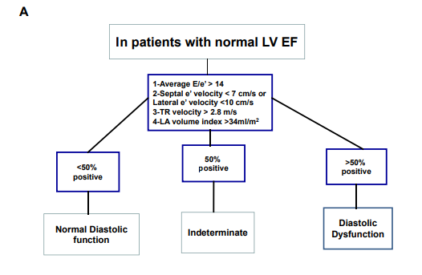
Variables from T7 needed for this classification:
LV ejection fraction. Exclude those with EF <50%
LVEFBIPLANE_T72
Average E/e’:
esum=(TDIESEPT_T72+TDIELAT_T72)/2; : average septal and lateral tissue Doppler peak e’
aver_E_e=MVEVMAX_T72/esum;
Septal e’ velocity < 7 cm/s or lateral e’ velocity <10 cm/s:
TDIESEPT_T72<0.07 or TDIELAT_T72<0.1
TR (Tricuspid Regurgitation) velocity >2.8 m/s:
TRVMAX_T72>2.8
LA volume index >34 ml/m²: (see how to define lavi above in the Heart Failure section)
lavi>34
Full SAS syntax for diastolic dysfunction classification
data rocdiast;
set work_combined_2;

if 0<LVEFBIPLANE_T72<50 then delete;

*DD;
avr=0;
if aver_E_e>14 then avr=1;

tdi=0;
if TDIESEPT_T72<0.07 or TDIELAT_T72<0.1 then tdi=1;

tr=0;
if TRVMAX_T72>2.8 then tr=1;

lav=0;
if lavi>34 then lav=1;

DD=sum(avr,tdi,tr,lav);

if DD=0 or DD=1 then dfunc=1;
if DD=2 then dfunc=2;
if DD>2 then dfunc=3;

After calculations those with dfunc=1 can be considered as persons without diastolic disfunction (<50% of positive markers), dfunc=2 : individuals with indeterminate (probable) diastolic dysfunction (50% of positive markers) or dfunc=3 : persons with diastolic dysfunction (>50% of positive markers).

